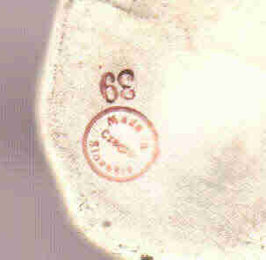 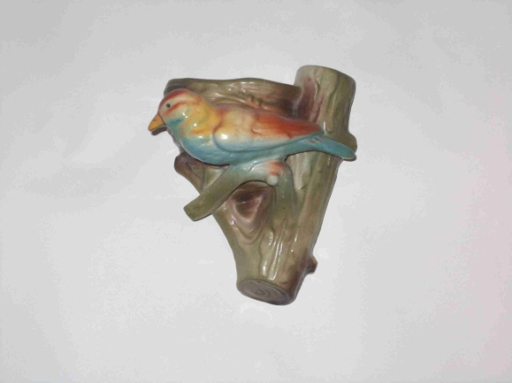 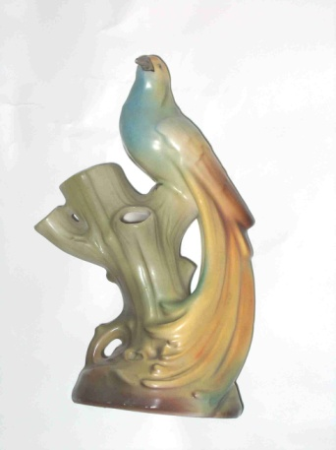

Red dime mark “Made in Czechoslovakia” found on the birds I collect. This example also shows the mold number found on wall pockets that is used to identify the particular bird and size.

This 9 ½ inch tall fantail bird is the large size of the more common style which is 5 inches tall

At first glance this looks like the common bird on the nest WP but this bird faces left instead of the more common right-facing bird.

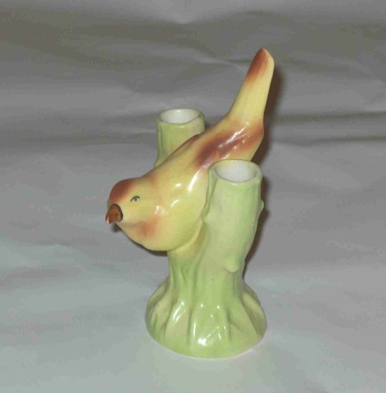 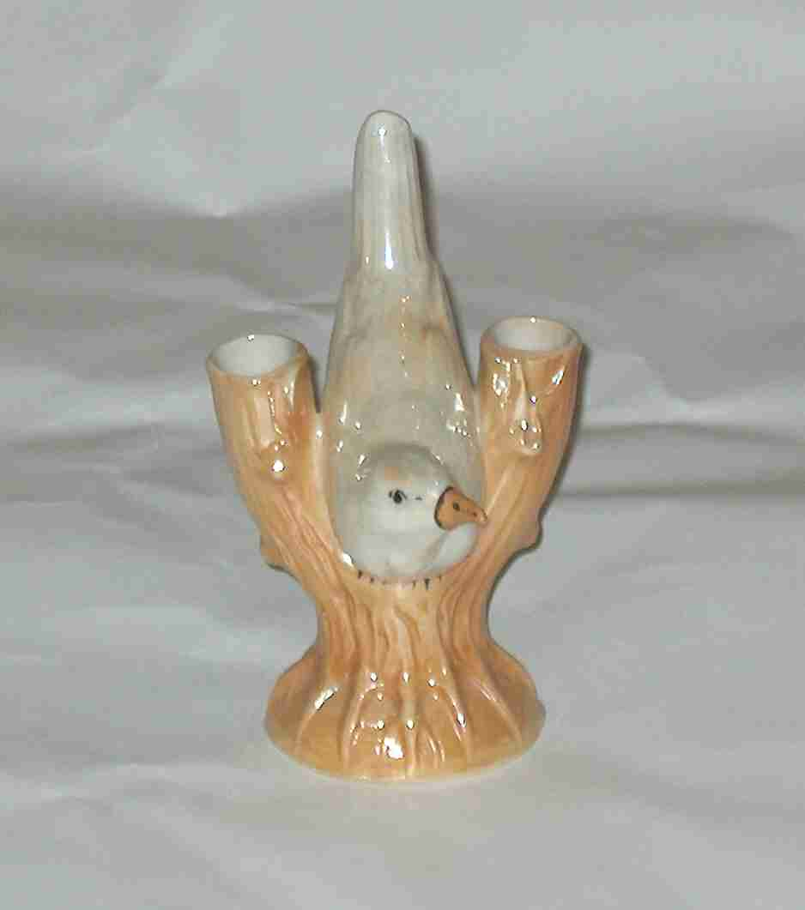 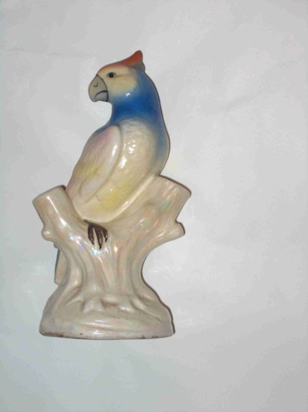

Cockatoos can be found in several sizes from 5-9 inches and several color combinations. This is the white luster tree trunk.

This bird between two tree trunks is found in luster, both white and the hard to find gold luster tree trunk